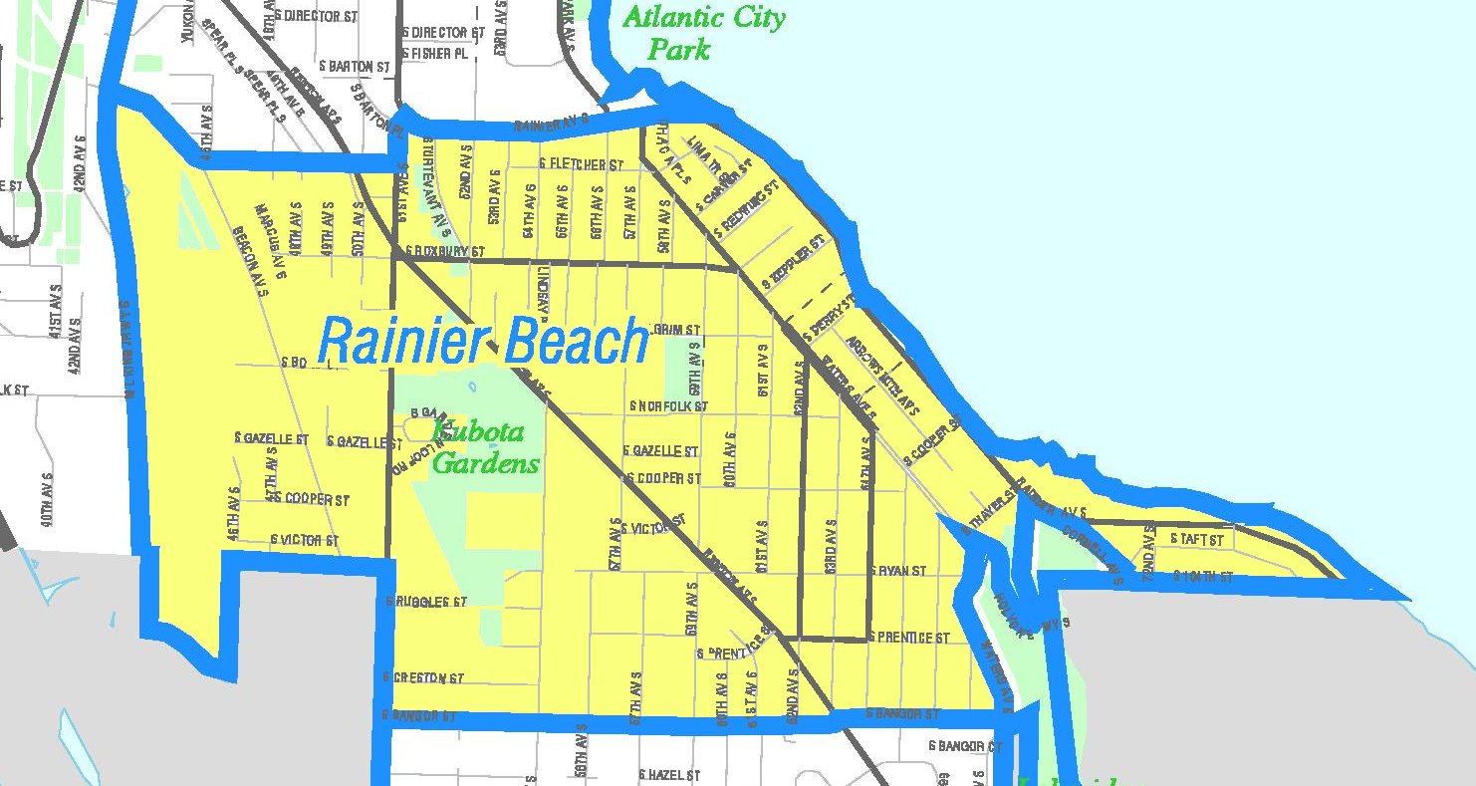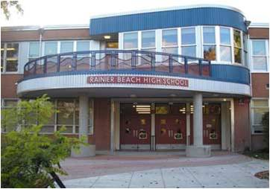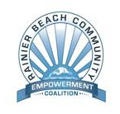

*Light refreshments will be provided. This is a child friendly environment.*

*Sponsored by:*   
  
**Rainier Beach Moving Forward**

**&**

**For more information contact:   
Gregory Davis at 206.914.1762 email: rainierbeachneighborhood@hotmail.com**

*When:* Thursday, August 22nd *Time:* 6:30pm – 8:30pm

*Where*: NeighborCare’s   
 Community Meeting Room  
 9245 Rainier Ave.

**Guests, Principal Dwayne Chapelle of Rainier Beach and neighboring school representatives will address:**

* **How do we build a bridge between the classroom and our respective community?**
* **Latest academic reports of neighborhood schools**

Through conversation we will review the emerging academic initiatives in Rainier Beach

**You are invited to join with other neighbors in a conversation about**  ***Academics in Rainier Beach***

**RB:** **Life Long Learning**

**Action Team**