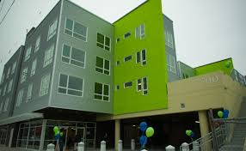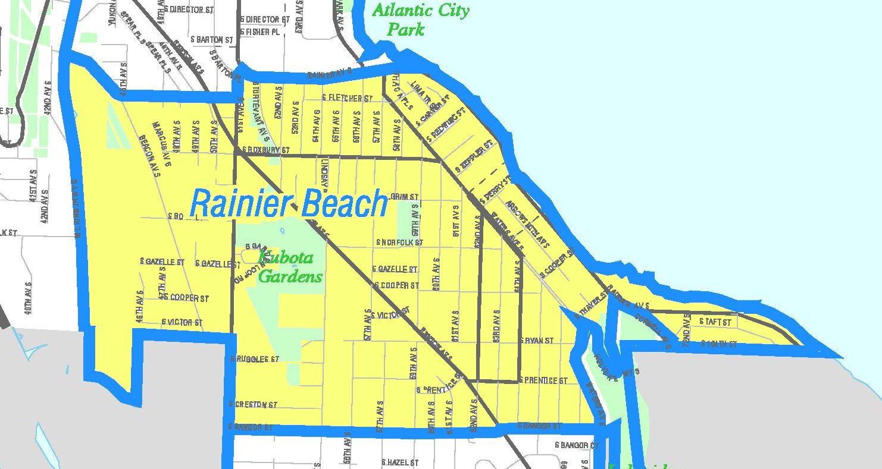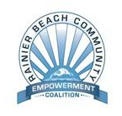

* **What’s missing?**
* **What can Race and Social Justice look like in RB?**
* **What’s next!**

*Light refreshments will be provided. This is a child friendly environment.*

*Sponsored by:*   
  
**Rainier Beach Moving Forward**

**&**

**For more information contact:   
Gregory Davis at 206.914.1762 email: rainierbeachneighborhood@hotmail.com**

*When:* Thursday, May 22nd *Time:* 6:30pm - 8pm

*Where*: NeighborCare’s   
 Community Meeting Room  
 9245 Rainier Ave.

We will continue the conversation began at the RB Town Hall Meeting, building upon our excitement!

**You are invited to join with other neighbors in a conversation about**  ***Housing, Transit & Development***

**RB:** **A Place for Everyone**