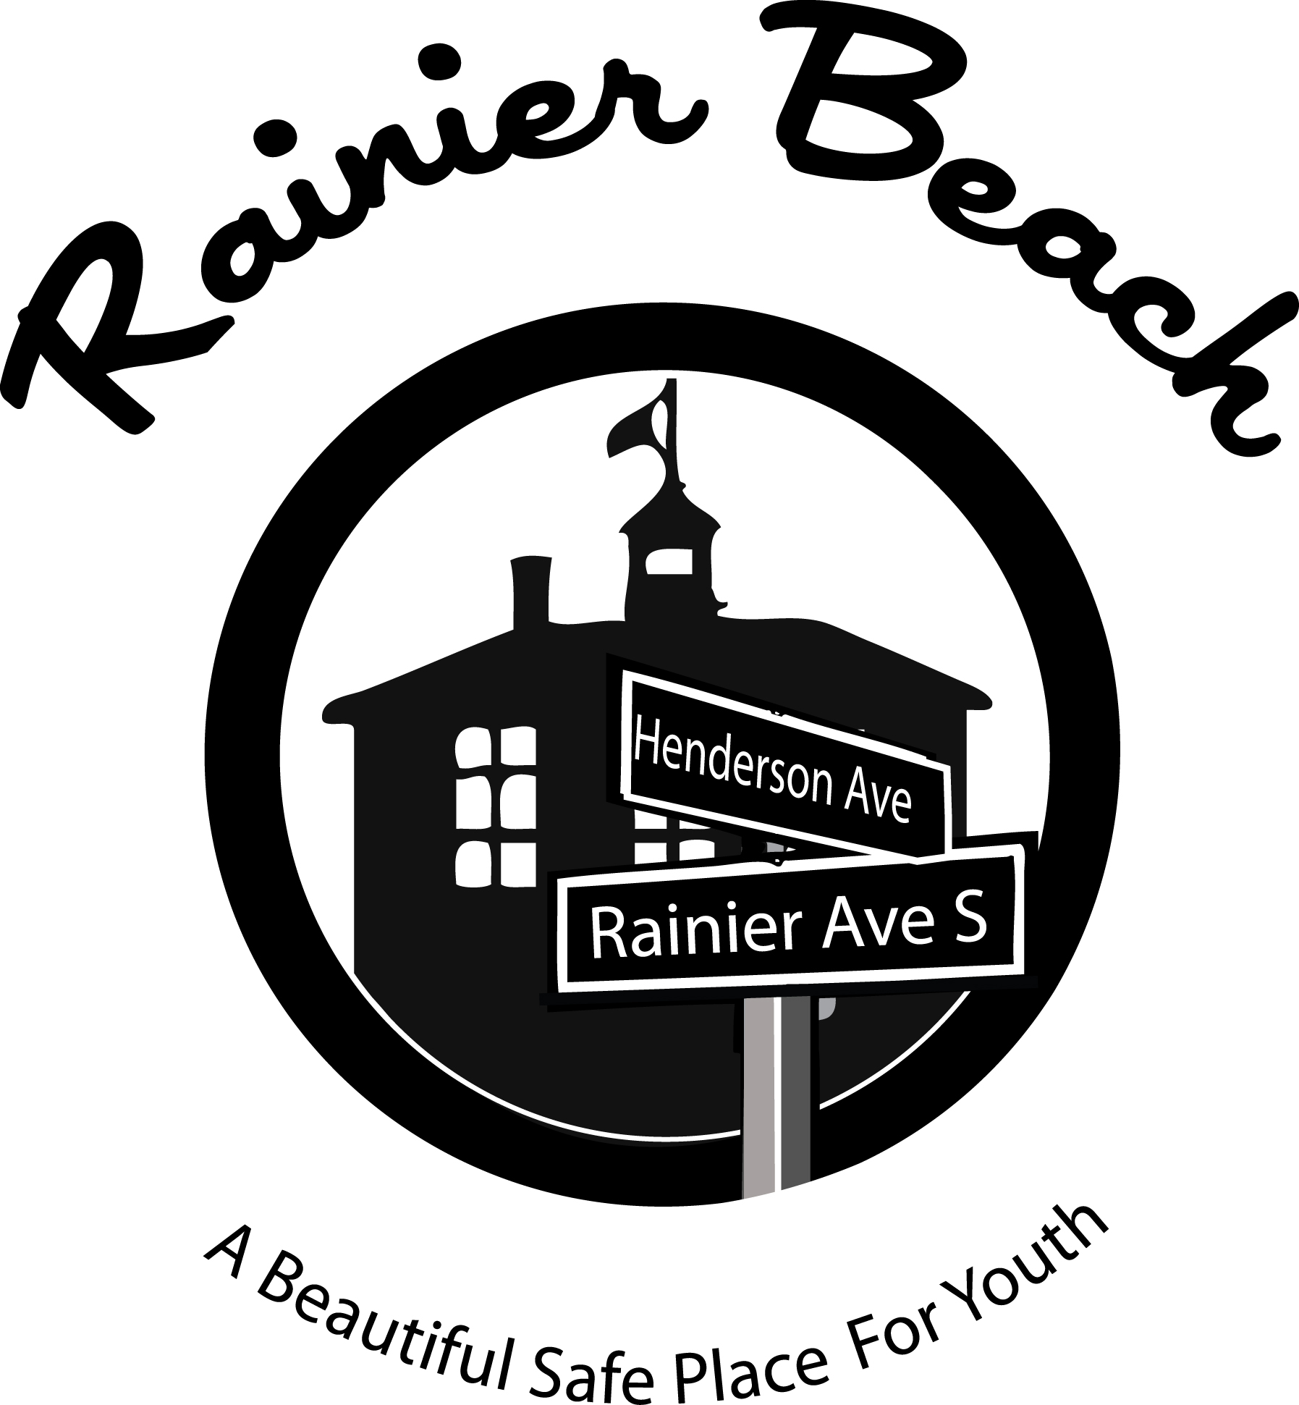
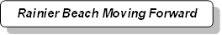
= RBAC
Rainier Beach Moving Forward
Rainier Beach Moving Forward

Organization: Rainier Beach Community Empowerment Coalition/and Rainier Beach Moving Forward=RBAC
Project Name: Rainier Beach - A Beautiful Safe Place for Youth (ABSPY)
Position Title: Youth Engagement Worker
Reports to: RBMF ABSPY Coordinator
Position Status: Contract
Contract Period: Upon hire to September 31, 2015
Compensation: $1,500

Description of Work
Under the supervision of the RBMF ABSPY Coordinator, represent RBCEC/RBMF=RBAC in its efforts to provide interventions aimed directly at the place-based risk factors that impact youth crime in five hotspot (“community engagement points”) locations.

Essential Elements
- Increase the number of community-building or improvement projects in which youth participate in partnership with community organizations.
- Increase the number of community-building or improvement projects in which youth provide leadership and development support.
- Increase in youth participation in structured activities after-school hours and summer months
- Increase of youth observing personal safety practices and reporting of criminal activity
- Increase in trust between youth and SPD
- Increased youth knowledge of local community issues and likelihood youth will engage in civic and other activities that promote the common good

Youth Truths
- Work in the Rainier Beach Neighborhood (five “citizen engagement points”)
- Engage neighborhood communities and youth to promote the true beauty and safety of the Rainier Beach neighborhood
- Work with a group of your peers and ABSPY Outreach Workers,
- Meet with the neighborhoods leaders
- Attend and participate in the creation of media from the home that you call Rainier Beach.
- Create a video documentation of your shared truths and experiences as the youth who live within the neighborhood that is known as “The Beach”
- Take ownership of this movement and at the end of the year show physical evidence that the Youth of Rainier Beach are as incredible as any youth in the nation
Schedule
Two days per week, three hours per day, up to 24 hours per month another way to look at it is eight events or meetings per month. *Subject to change due to previously schedule event or predetermined date and time

To Apply
Fill out form on next page, turn in to Guyanthony Parramore tonight. Must be high school age to apply, Rainier Beach resident preferred.

RBCEC/RBMF=RBAC youth and neighbor engagement interventions area a project of Rainier Beach: A Beautiful Safe Place for Youth and is made possible by Byrne Criminal Justice Innovations Grant # 2012-AJ-BX-0006 and the support of Seattle Neighborhood Group and the Seattle Youth Violence Prevention Initiative to develop and evaluate community-led crime prevention efforts.

Glossary of Terms

Term | Definition
Cultural appropriate outreach
Coordination support
Engage youth
Involve youth
Local neighborhood activities
Connections
Multiple communities
Increase the number
In Partnership with
Provide leadership
Development support
Structure activities
Paramount
Fun cultural diverse environment
Adaptability
Areas prone to violence and crime
Follow the lead of youth

Tear Here and return

Name School
Address, City Zip
Phone Number
Email
Facebook
Instagram
Why are you interested?

